Name: _________________________ Period: ___________ Practice 8.4B

Solve. Check for extraneous solutions.
1. $\frac{6}{x^{2}}=\frac{2}{5x}$ 2. $\frac{1}{x}+\frac{4}{x+3}=1$

3. $\frac{3}{x}+\frac{1}{x-2}=\frac{5}{x}$ 4.$\frac{4}{x-2}=\frac{x}{x+4}$

5. $\frac{x}{9}-\frac{1}{x}=\frac{7}{9x}$ 6. $\frac{3}{x^{2}+4x+3}=\frac{6}{x^{2}+5x+4}$

7. $\frac{5}{x-7}=\frac{2}{x-4}$ 8. $\frac{4}{x+1}+\frac{3}{x^{2}-1}=1$

9. $\frac{x}{x+3}-\frac{2}{x+2}=\frac{x}{x^{2}+5x+6}$ 10. $\frac{16}{x^{2}+8x}=\frac{4}{x}$

11. $\frac{2}{x+1}=\frac{x}{x^{2}+2x+1}$ 12. $\frac{2}{x^{2}+x-6}-\frac{1}{x^{2}-x-6}=\frac{1}{x^{2}-9}$

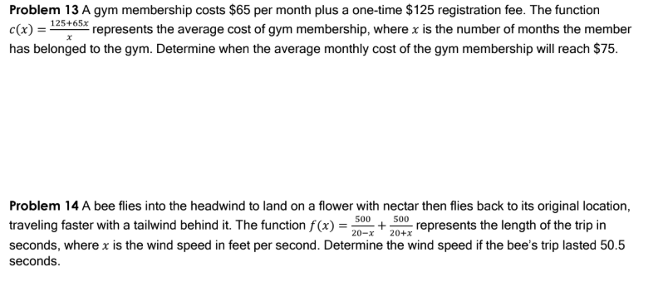

15. $\frac{3x}{x + 4} + \frac{4x}{x - 3} = \frac{84}{x^{2} + x - 12}$

16. $\frac{x + 2}{x - 3} + \frac{x - 2}{x - 6} = 2$

17. $\frac{2}{x + 2 } - \frac{x}{2 - x } = \frac{x^{2} + 4}{x^{2} - 4}$ 18. $\frac{1}{ 1 - x} = 1 - \frac{x}{x - 1}$

19. $\frac{4x}{x^{2}- 9} - \frac{x - 1}{x^{2}- 6x + 9}= \frac{2}{x + 3}$ 20. $\frac{x + 3}{2x - 3} = \frac{18x}{{4x}^{2} - 9}$

